# DAILY ASSESSMENT

|  |  |  |  |
| --- | --- | --- | --- |
| Date: | 16/07/2020 | Name: | Chesmi B R |
| Course: | **Computer vision basics** | USN: | 4AL16EC100 |
| Topic: | **Week4: aligning RGB channels** | Semester & Section: | 8TH SEM & A Section |
| Github Repository: | Chesmibr |  |  |

|  |
| --- |
| **FORENOON SESSION DETAILS** |

One very common operation with spacecraft images is to make a color image from individual frames captured through different filters.  To make approximate true color images, an image of the same target needs to be captured through red, green, and blue filters at about the same time.  False color images can be made from any combination of three filters.

If you'd like to try this at home, you will need:

* A copy of Adobe Photoshop.  The screen caps in this tutorial are from Photoshop CS3, but earlier versions will also work. (Note: making RGB images is possible with many off-the-shelf, shareware, or freeware image processing packages; this tutorial presently covers only Photoshop.)
* Three images captured through different color filters

Consider these three images taken from the Cassini raw images website.  They were taken by Cassini on June 15, 2007 and show the moon Rhea against Saturn's globe.  From left to right, they were taken through red, green, and blue filters. These images are courtesy of NASA, JPL, and the Space Science Institute.

#### Preliminary Note about Image Credits

All raw images posted on NASA mission websites are in the public domain. However, you should always give credit to the appropriate institutions for taking the original images. Each mission's website will offer guidance on how images shoud be credited.

(For clarity, from here forward these images will be shown cropped more tightly around Rhea.)

This tutorial will show you how to convert three grayscale images into one color image.  However, if you go straight to that step, you will find that because Cassini is not a fixed platform but instead a moving orbiter, Rhea shifts from frame to frame.  If you do not align the frames before merging them, you will produce an image that looks like this, where each sharp edge is fringed with color:  
If images captured through different filters are not aligned, color fringes will appear around sharp edges in the image. Credit: NASA / JPL / SSI / Emily Lakdawalla

### Aligning the Frames

Begin by opening the three different-filter images of Rhea.

1. Paste the three frames into layers on one image.
   1. Begin with the Blue-filter image.
   2. Go to the Green-filter image, select all (**Ctrl-A** or **Select > All**), copy (**Ctrl-C** or **Edit > Copy**), return to the Blue-filter image, and paste (**Ctrl-V** or **Edit > Paste**).
   3. Repeat the step with the Red-filter image.
   4. You should now have one image with three layers.  The Blue-filter image is on the bottom as the background layer, the Green-filter image is in the middle as Layer 1, and the Red-filter image is on top as Layer 2.
   5. Now would be a good time to save (**Ctrl-S** or **File > Save**).  
      The three images have now been stacked as layers in a single Photoshop document. In this example, the Blue filter image is the Background layer, the Green filter image is Layer 1, and the Red filter image is Layer 2. Credit: NASA / JPL / SSI / Emily Lakdawalla
2. Increase the size of the image
   1. Go to **Image > Image Size...** and make the image 200% or 300% its original size.  This step will permit you to make finer adjustments to the alignment of the frames.
3. Align the green-filter image to the blue-filter image
   1. In the Layers palette, turn off the top layer (Layer 2) by clicking the eye icon next to it.
   2. Make the middle layer (Layer 1) active by clicking the text "Layer 1."
   3. Set the blending mode for this layer to Difference by using the drop-down menu in the Layers palette.  This blending mode subtracts one of the layers from the other.  Since the two layers are very similar the image will now appear mostly black, because the two layers will nearly cancel each other out.  However, where they are poorly aligned, there will be white fringes.

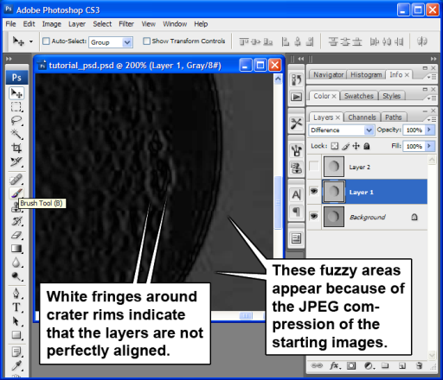  
  
With one layer set to the Difference blending mode, that layer's pixel values are subtracted from the ones below it. The result is an image that is nearly black (because the two images are largely similar), but there are bright fringes because the two layers are not perfectly aligned. Credit: NASA / JPL / SSI / Emily Lakdawalla

* 1. Using the Move tool (Photoshop Move tool), move Layer 1 around until the white fringes disappear (or are minimized).  If the necessary adjustments are small, it may be easiest to use the arrow keys on your keyboard to nudge the layer back and forth.
  2. Set the blending mode back to Normal.

1. Align the red-filter image to the blue-filter image
   1. In the Layers palette, turn off Layer 1 and turn on Layer 2.
   2. Repeat steps 3b through 3e for Layer 2.
2. Crop the image so that every layer reaches the edge of the canvas
   1. Because you moved layers around, there will be "blank" or "transparent" areas at the extreme edges of some layers.  These transparent areas can cause problems later when you paste the layers into a new document.  You want to crop these transparent areas away from the image.  You can do this either using the Crop tool (Photoshop Crop tool) or by shrinking the size of the canvas (**Image > Canvas Size…**)
   2. Now would be a good time to save.

### Merging the aligned frames into an RGB image

1. Make the background layer (the blue-filter image) the active layer by clicking on its name in the Layers palette.
2. Copy the layer (select all and copy).
3. Create a new, blank RGB image (**Ctrl-N** or **File > New**; Photoshop will automatically fill in the Width and Height of your copied image; select "RGB Color" for the Color Mode.)  
   Activate the Channels palette by clicking the Channels tab next to the Layers tab.
4. Click on the Blue channel.
5. Paste the layer (Ctrl-V or Edit > Paste).
6. The blue channel now contains the blue-filtered Cassini image.  You may notice that the RGB image in the Channels palette looks yellow.

**Tutorial: RGB images: channels**  
The new color image now has one of its channels filled in, the blue channel. Because the red and green channels have not been filled in yet, the resulting RGB image appears yellow. (The red and green channels have all-white, or maximum-value pixels, and red and green light mixed together make yellow.) Credit: NASA / JPL / SSI / Emily Lakdawalla

1. Activate the Layers palette by clicking the Layers tab.
2. Return to the image containing your aligned layers.  Make Layer 2 (the green-filter image) active, select all and copy.
3. Return to the new color image, activate the Channels palette, select the Green channel, and paste.  The RGB channel will now look red.
4. Repeat steps 8-10 for the last layer, the red-filter image, pasting it into the Red channel.
5. Make the RGB channel active.  Your image should now look like this, with a yellowish Saturn and a grayish Rhea.
6. Save your artwork!
7. Finally, feel free to play around with the image's brightness, contrast, hue, and saturation using the various controls available to you in the **Image** men

**DAILY ASSESSMENT**

|  |  |  |  |
| --- | --- | --- | --- |
| **Date:** | **16/07/2020** | **Name:** | **Chesmi B R** |
| **Course:** | **Trailhead salesforce developer** | **USN:** | **4AL16EC100** |
| **Topic:** | **Platform development basics** | **Semester & Section:** | **8TH SEM & A Section** |
| **Github Repository:** | **chesmibr** |  |  |

|  |
| --- |
| **AFTERNOON SESSION DETAILS** |
|  |

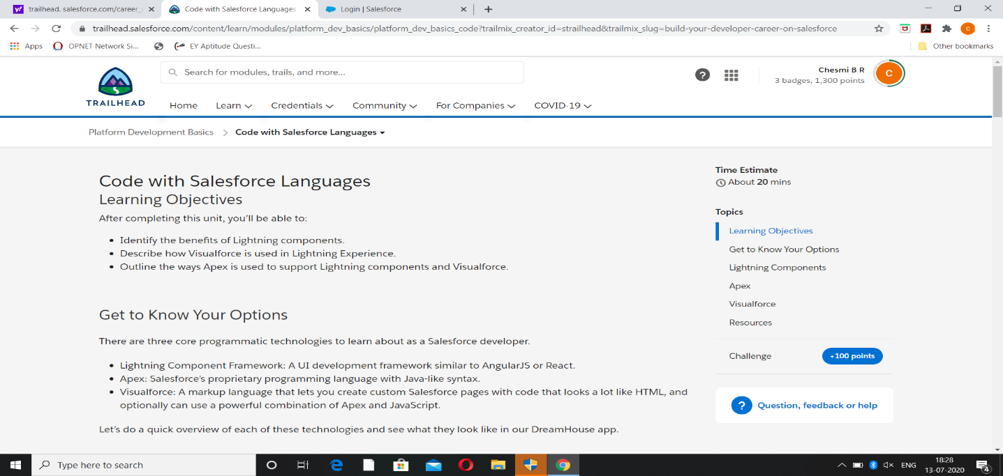

|  |
| --- |
| **Report**-  At Salesforce, we group our services by clouds. There’s Sales Cloud for CRM, Service Cloud for customer support, and a handful of other clouds that help companies support their business functions. And while each of these clouds serves a unique purpose, there’s one thing they all have in common: the power of the Salesforce platform.  What is the Salesforce platform, exactly?  Like any platform, the Salesforce platform is a group of technologies that supports the development of other technologies on top of it. What makes it unique is that the platform supports not only all the Salesforce clouds, but it also supports custom functionality built by our customers and partners. This functionality ranges from simple page layouts to full-scale applications.  If you’re here today, we’re assuming you know a bit about software development. Throughout this module, we’re going to give you an overview of development on the Salesforce platform. We talk about some of the pillars of Salesforce development and how they work together to create a robust system. We even touch on some common questions that developers new to the platform run into as they get started.  Before we continue, let’s make sure we’re on the same page. If you’re brand new to Salesforce and you haven’t completed the [Salesforce Platform Basics module](https://trailhead.salesforce.com/modules/starting_force_com), we suggest you do that before you keep reading.  Once you’re done with that, you’re ready to get started! Platform Building Blocks As we mentioned, the platform not only forms the foundation of core Salesforce products like Sales Cloud and Service Cloud, but it also lets you build your own functionality. Building your own functionality can mean customizing existing Salesforce offerings or it can mean building something from scratch.  Let’s focus on that latter part and talk about what the Salesforce platform offers developers.  Our core platform lets you develop custom data models and applications for desktop and mobile. And with the platform behind your development, you can build robust systems at a rapid pace.  And then there’s the Heroku platform. Heroku gives developers the power to build highly scalable web apps and back-end services using Python, Ruby, Go, and more. It also provides database tools to sync seamlessly with data from Salesforce.  And then there’s the host of Salesforce APIs. These let developers integrate and connect all their enterprise data, networks, and identity information.  And then there’s the Mobile SDK. The Mobile SDK is a suite of technologies that lets you build native, HTML5, and hybrid apps that have the same reliability and security as the Salesforce app.  And then... wait. Let’s stop for a second.  The problem with the platform and all its parts is that listing them out takes a really long time. And just talking about them doesn’t help you understand everything they do. Let’s take a different approach and talk about what we can do with the platform. Or, more precisely, what we can build with it.  The DreamHouse App  Let’s float a scenario. Throughout the rest of this module, we use this scenario to explore the many exciting tools and technologies that the Salesforce platform provides.  You’re a developer for DreamHouse Realty, a company that aggregates real estate listings to better connect homebuyers and real estate agents. Your boss asks you to build a new system to track real estate listings. Your internal employees will use it to track and communicate about properties. Your partner real estate brokers will use it to access information about customers. And your customers will view properties and contact brokers for viewings.  Building an app like this one from scratch isn’t an easy thing to do. Taking on this project in real life can involve a long, complicated list of functional requirements and the implementation of special integrations for your company’s business data. Working by yourself, it can take you months to get something out the door.  But before your stress builds and you melt into a puddle of existential dread, remember: You’ve got the platform. And building complex business applications at a breakneck pace is what the platform’s all about.  We’re going to show you a fully functional version of the DreamHouse app so you can get a feel for how it was built. As we move through, we discuss important Salesforce development concepts using the app to guide us. Install the DreamHouse App To follow along and practice the steps in this module, you need to install the DreamHouse package in your Trailhead Playground. Follow the instructions here to launch a playground and install the package. You also use this package and playground when it’s time to complete the hands-on challenge.  Launch your Trailhead Playground by scrolling to the bottom of this page and clicking **Launch**. If you see a tab in your org labeled Install a Package, great. Follow the steps below.  If not, from the App Launcher (App Launcher icon), find and select **Playground Starter** and follow the steps. If you don’t see the Playground Starter app, copy [this package installation link](https://login.salesforce.com/packaging/installPackage.apexp?p0=04tB00000009UeX) and check out [Install a Package or App to Complete a Trailhead Challenge](https://trailhead.salesforce.com/help?article=Installing-a-package-or-app-to-complete-a-Trailhead-challenge) on Trailhead Help.   1. Click the Install a Package tab. 2. Paste 04tB00000009UeX into the field. 3. Click **Install**. 4. Select **Install for All Users**, then click **Install**. |